1. Network devices

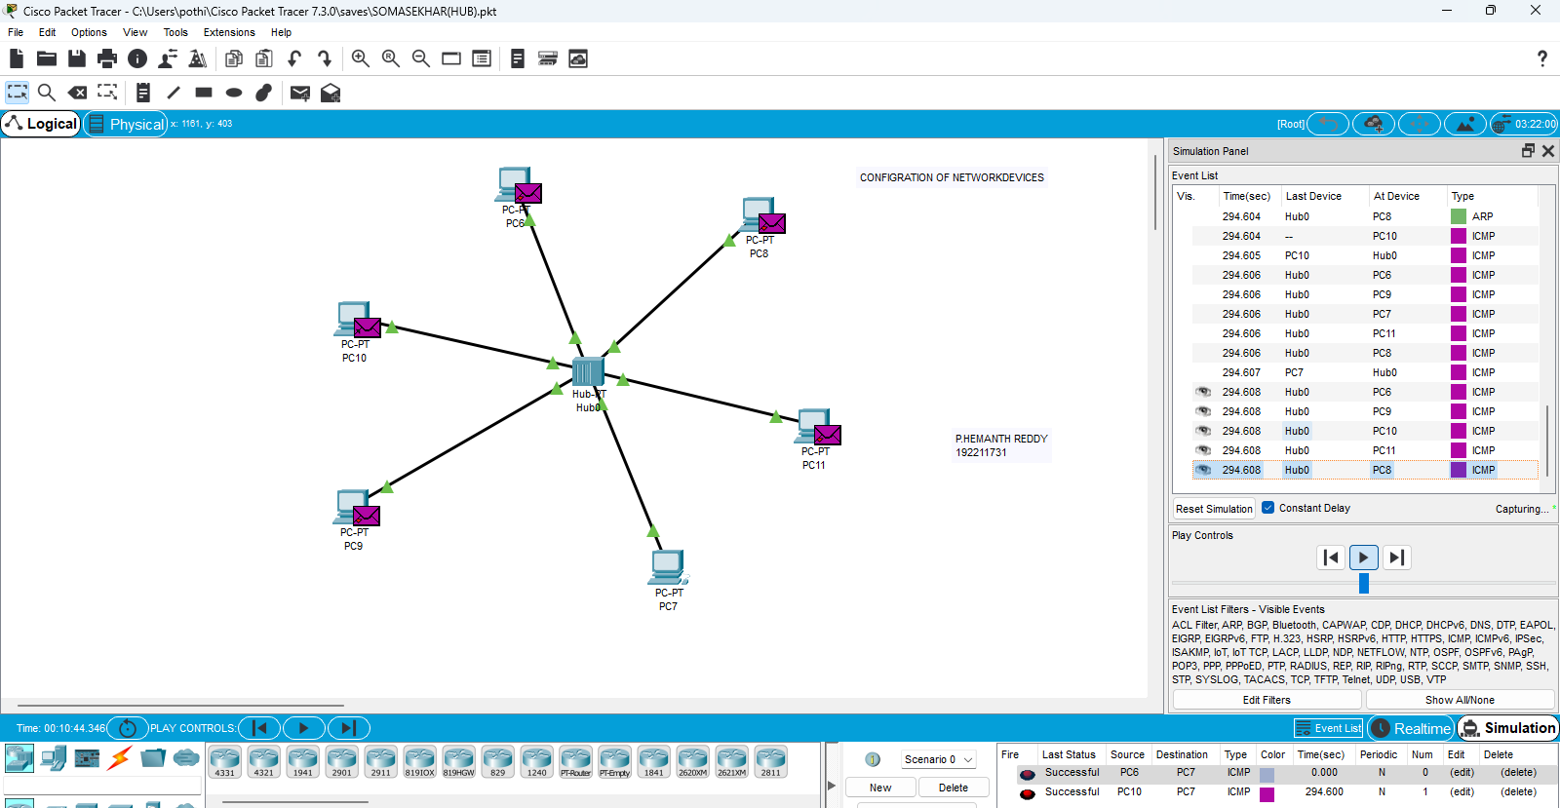

2. Star topologies

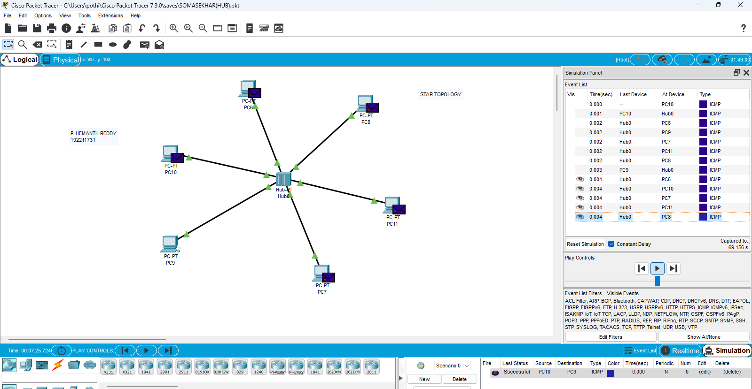

3. Bus toplogy

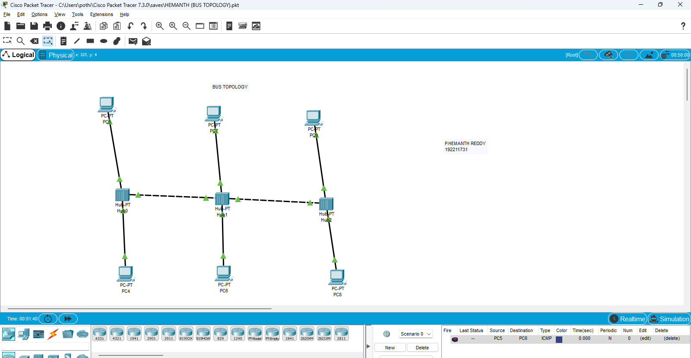

4.RING TOPOLOGIES

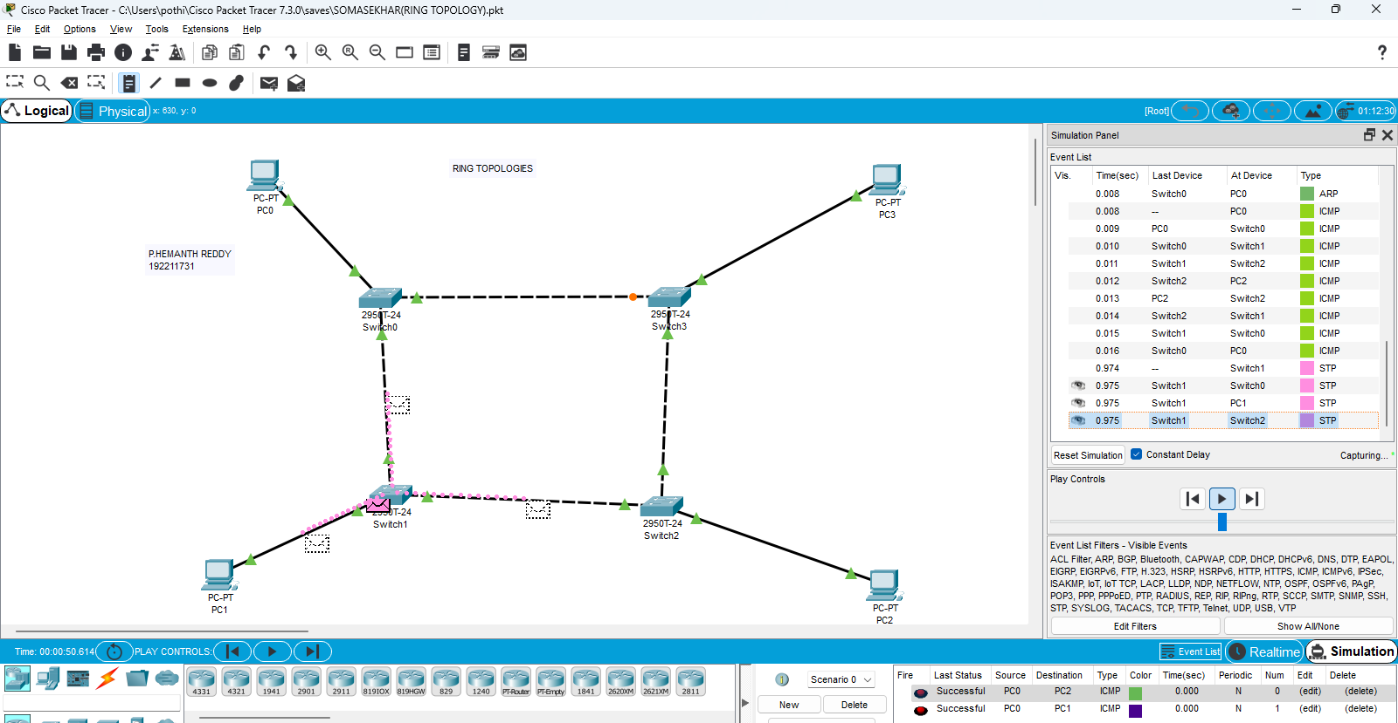

5. MESH TOPOLOGIES

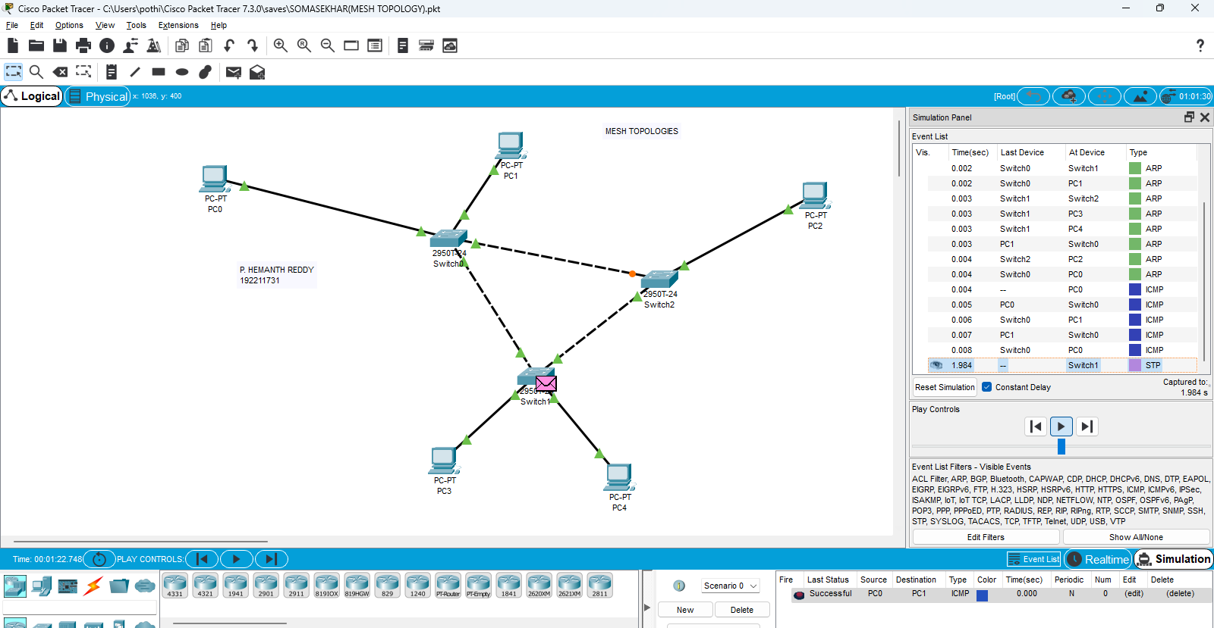

6.TREE TOPOLOGIES

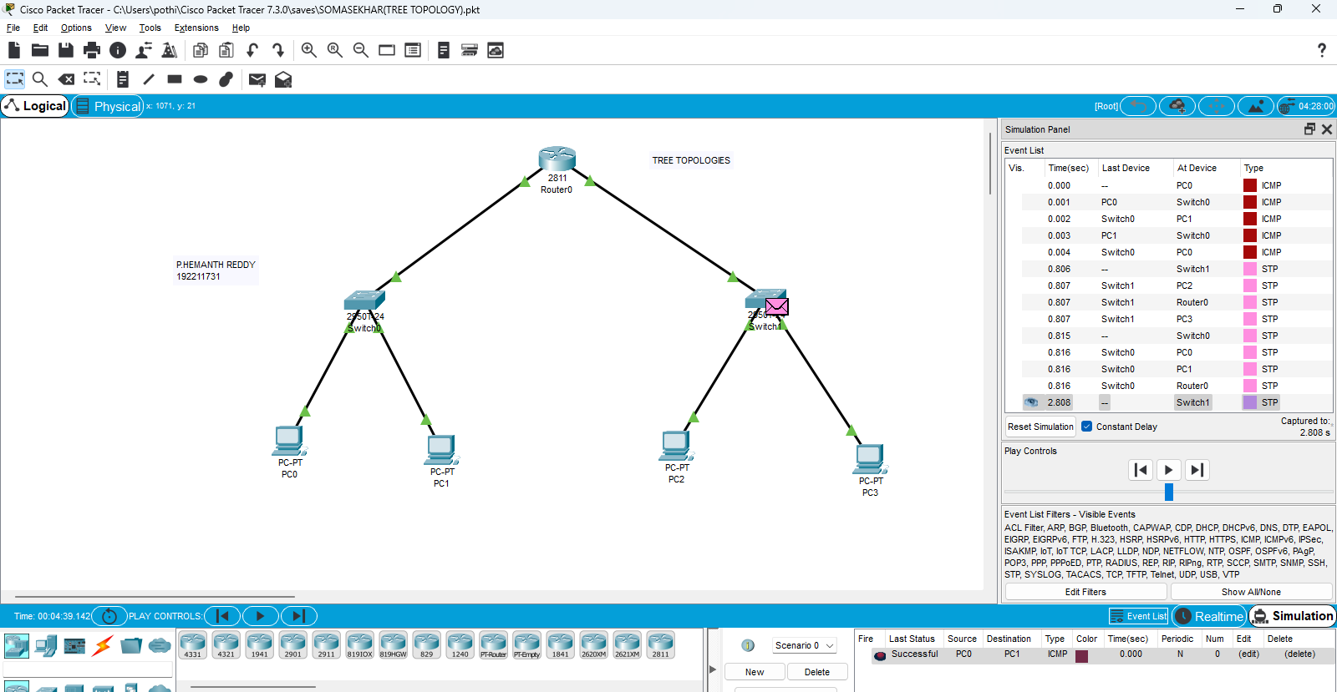

7.HYBRID TOPOLOGIES

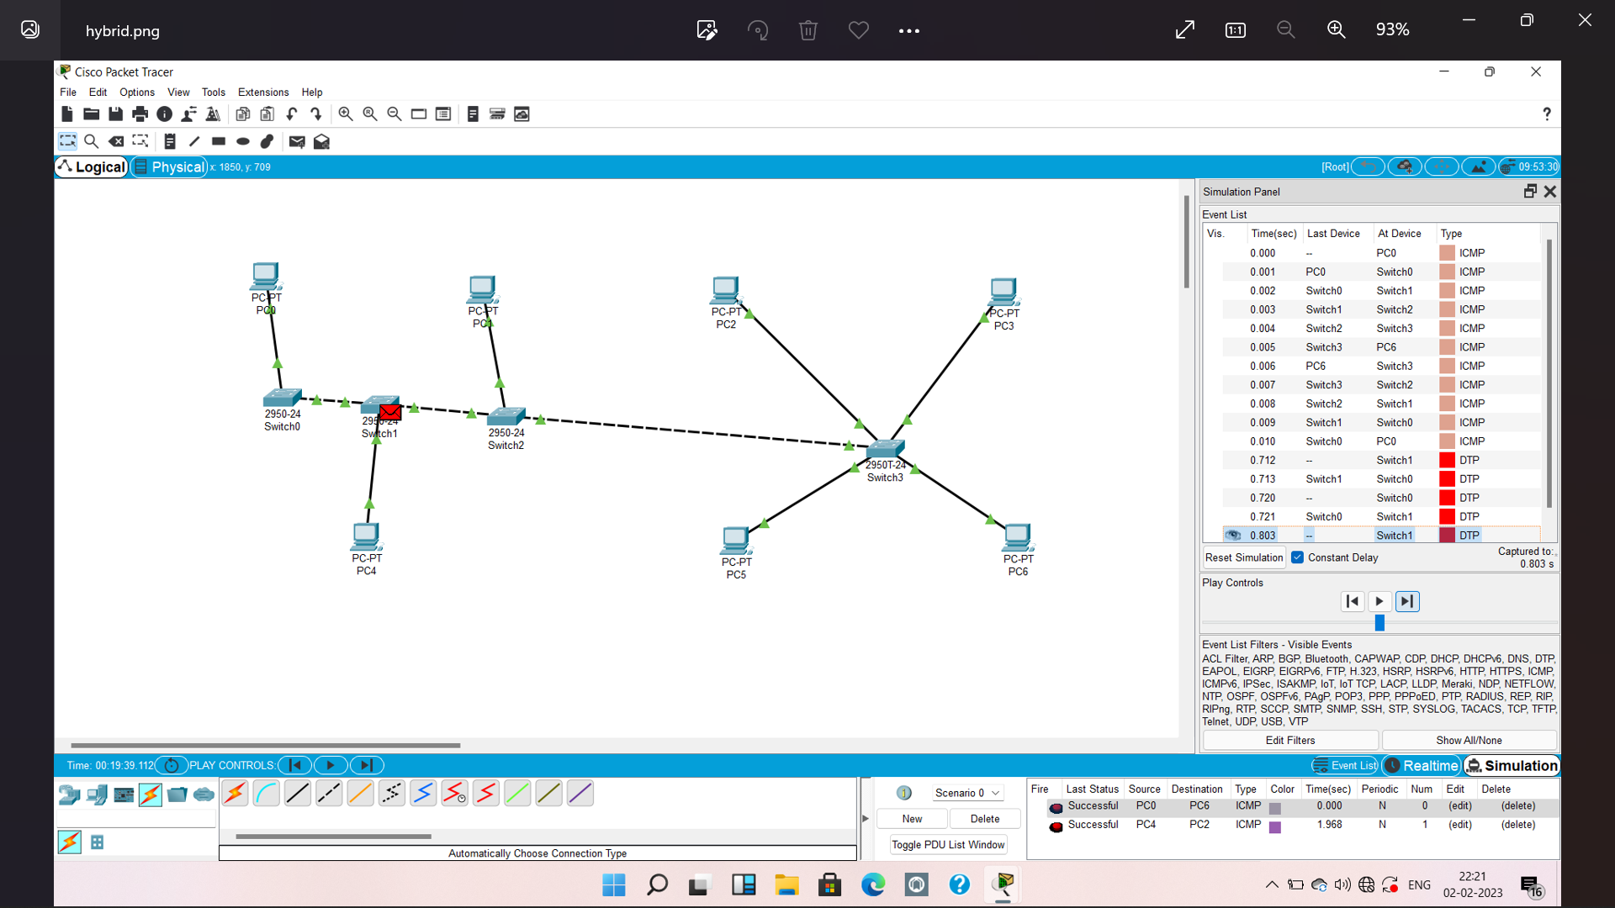

8.traffic simulation using ARP

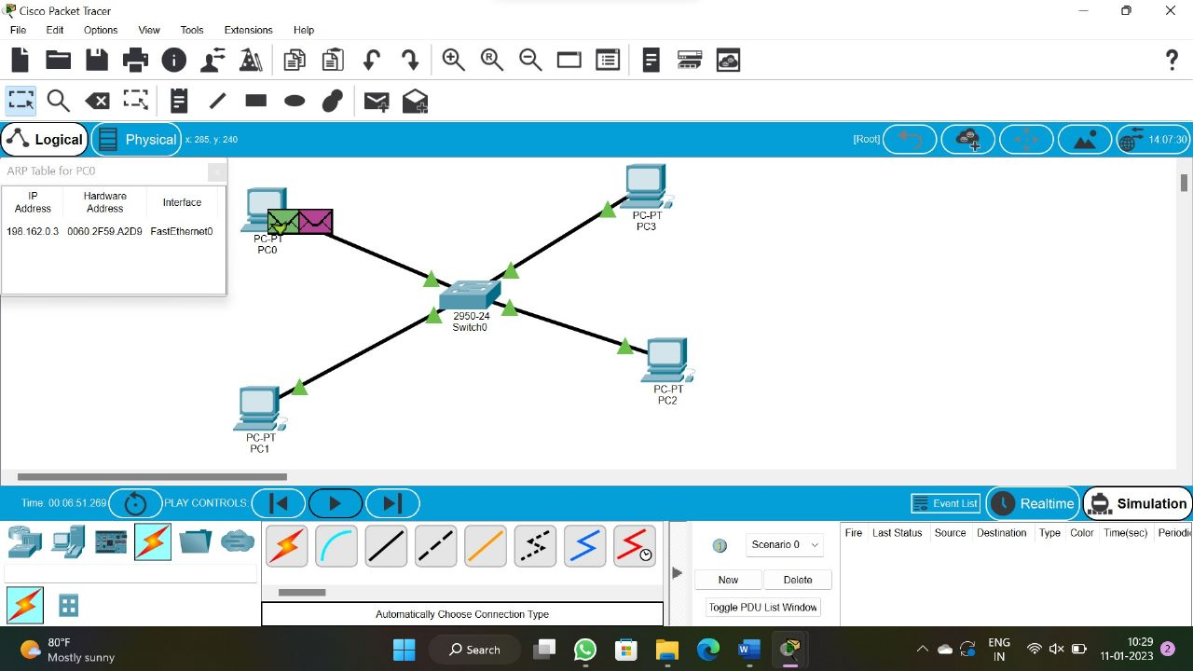

9. TRAFFIC SIMULATION USING LLDP

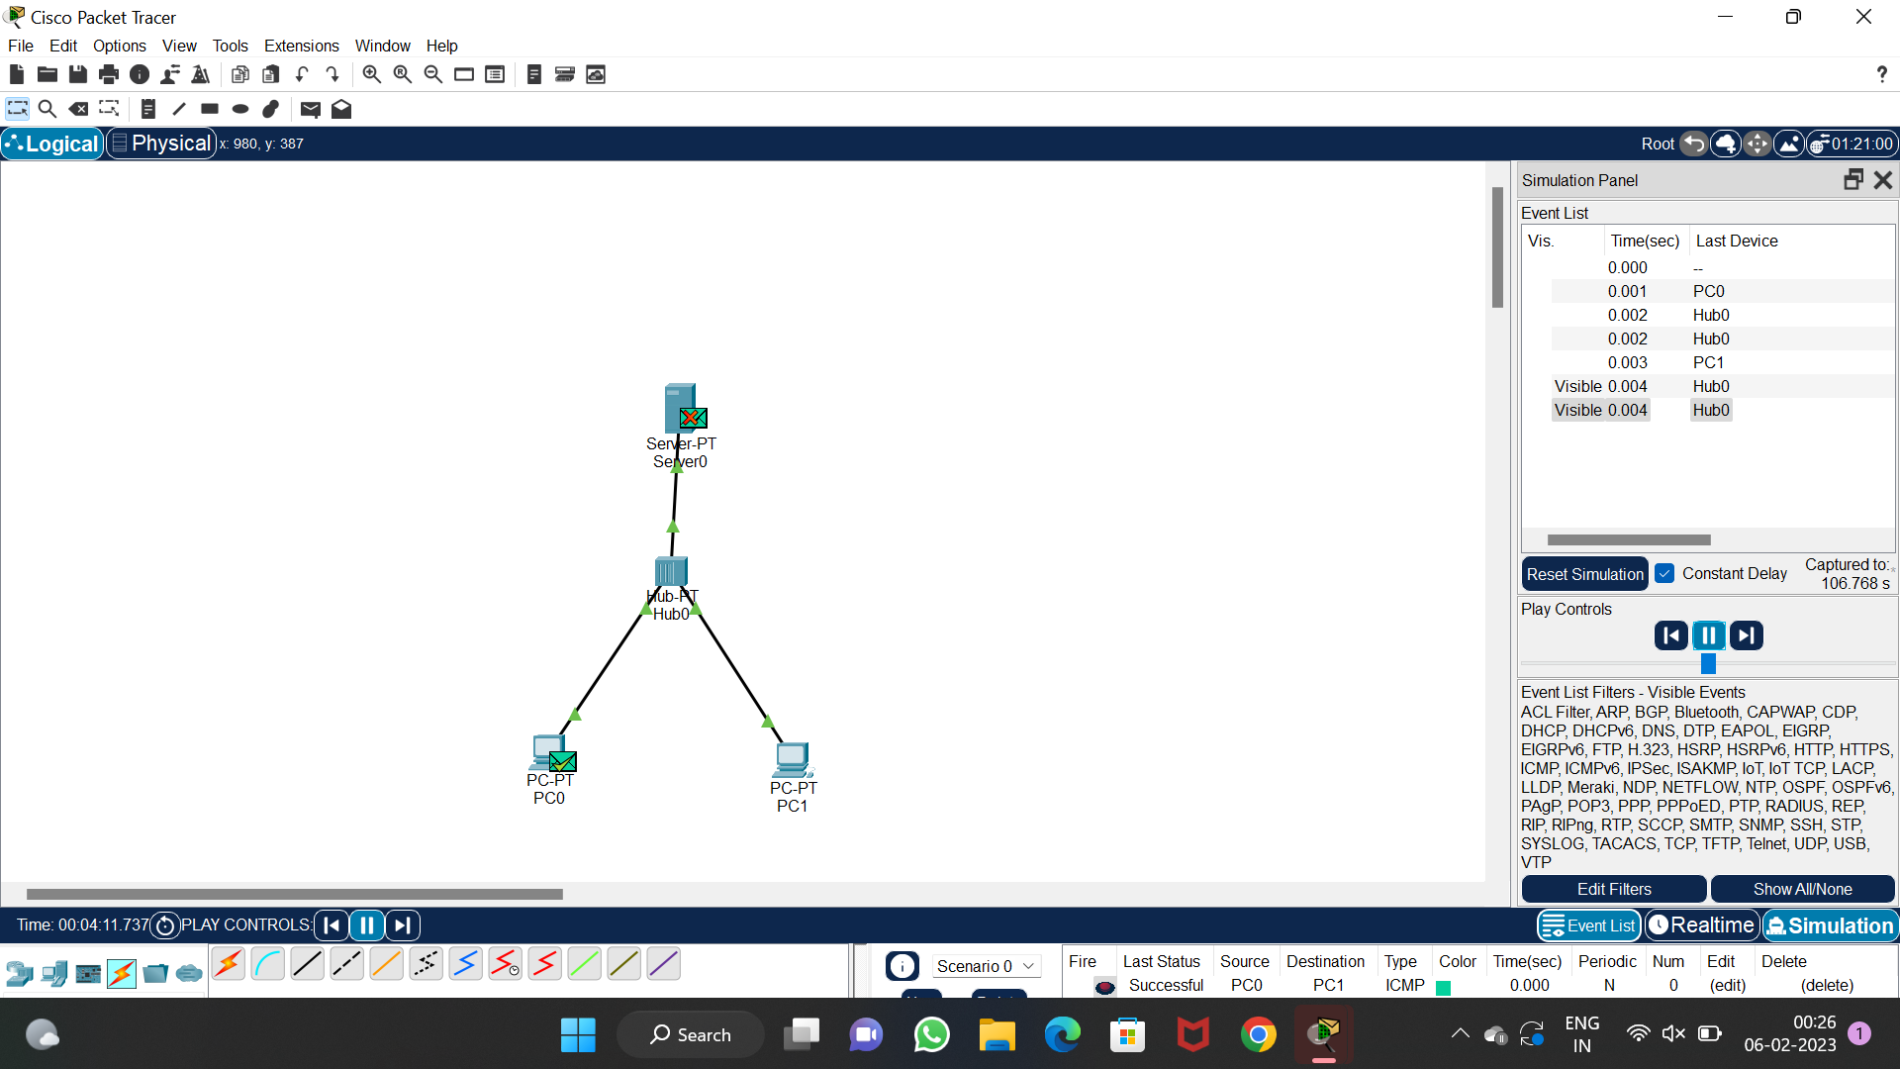

10. CSMA

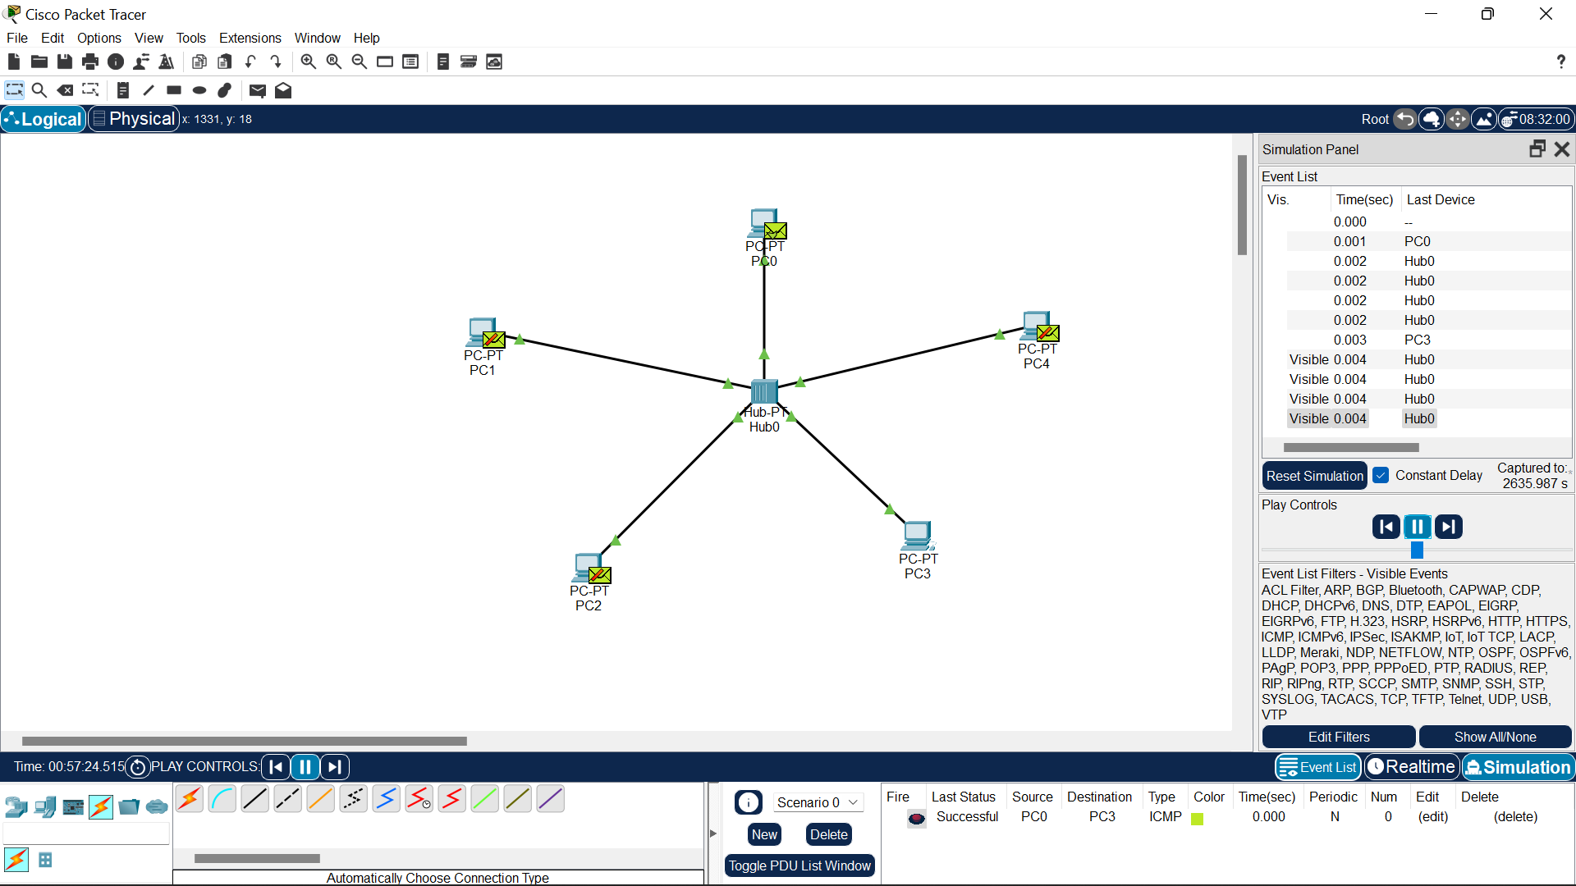

11. BIT STUFFING MECHANSIM USING C

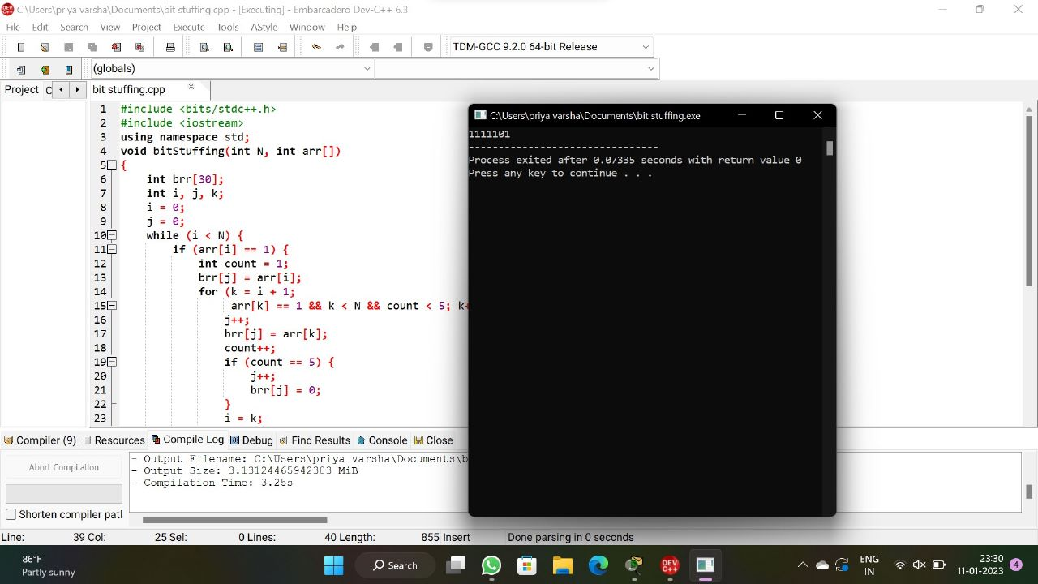

12. STATIC ROUTING

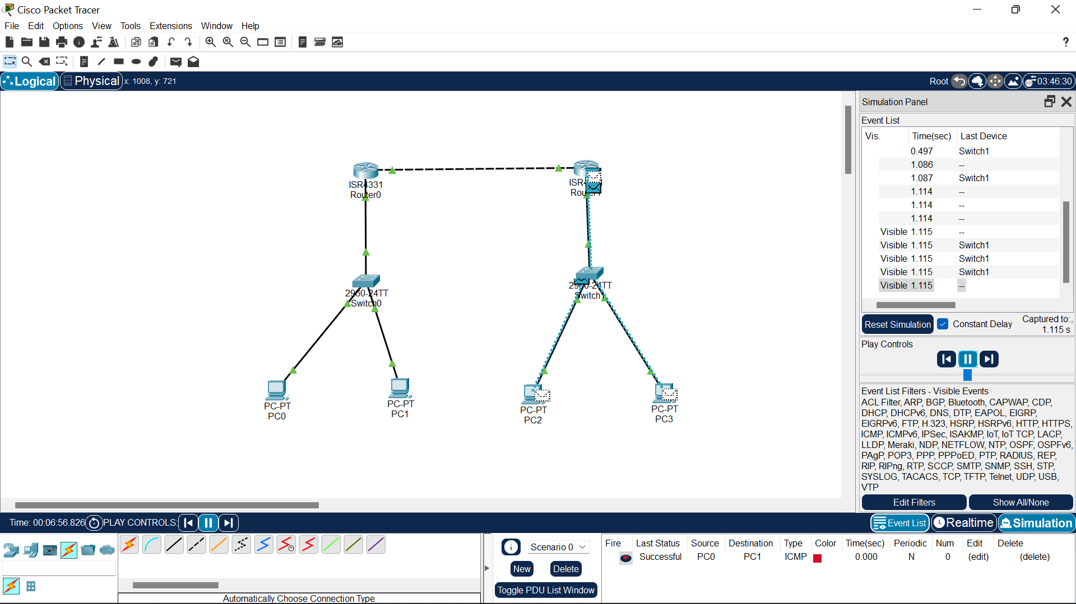

13.DYNAMIC ROUTING

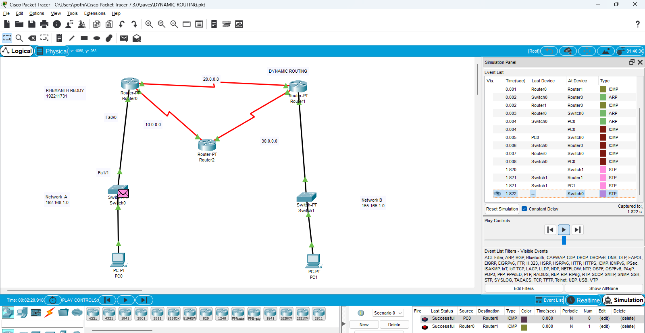

14. FUNCTIONALITIES OF TCP

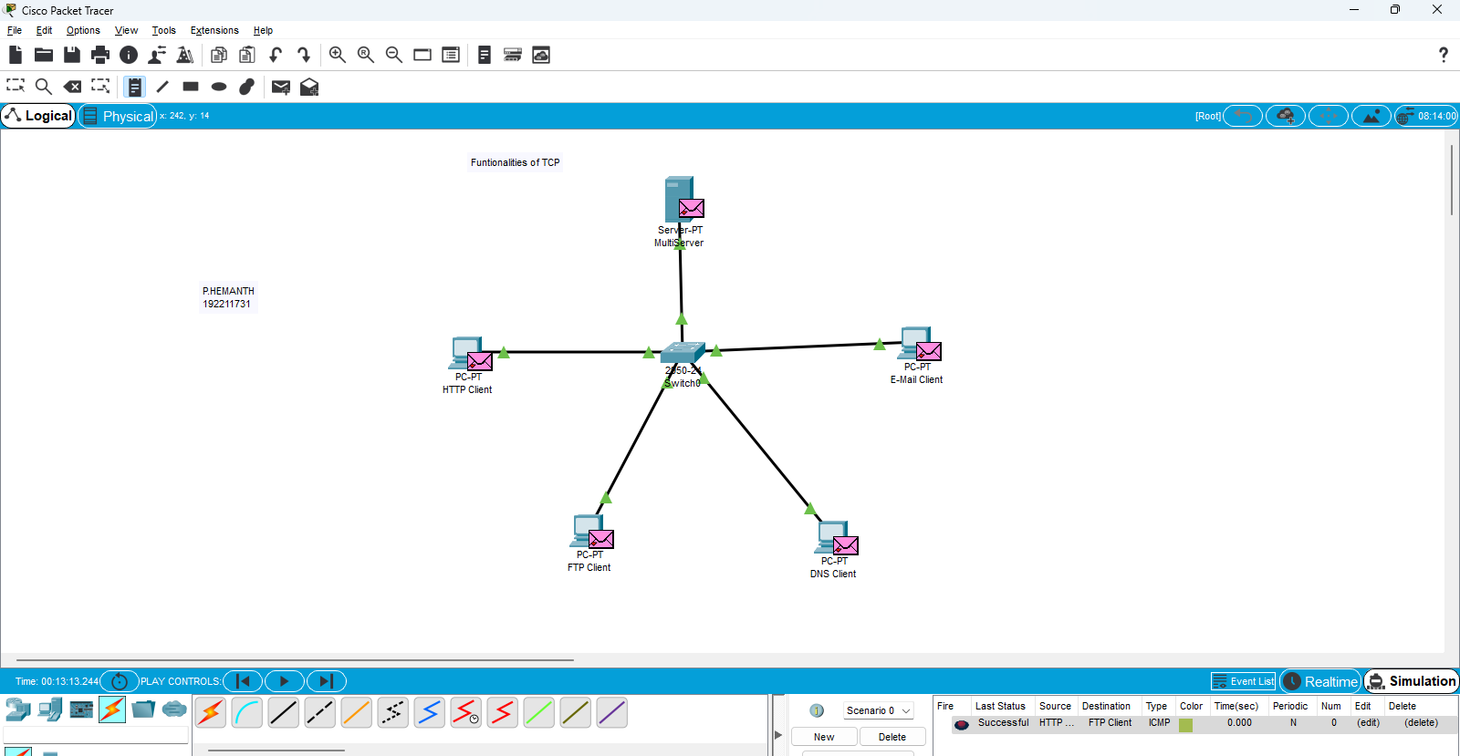

15. FUNCTIONALITIES OF UDP

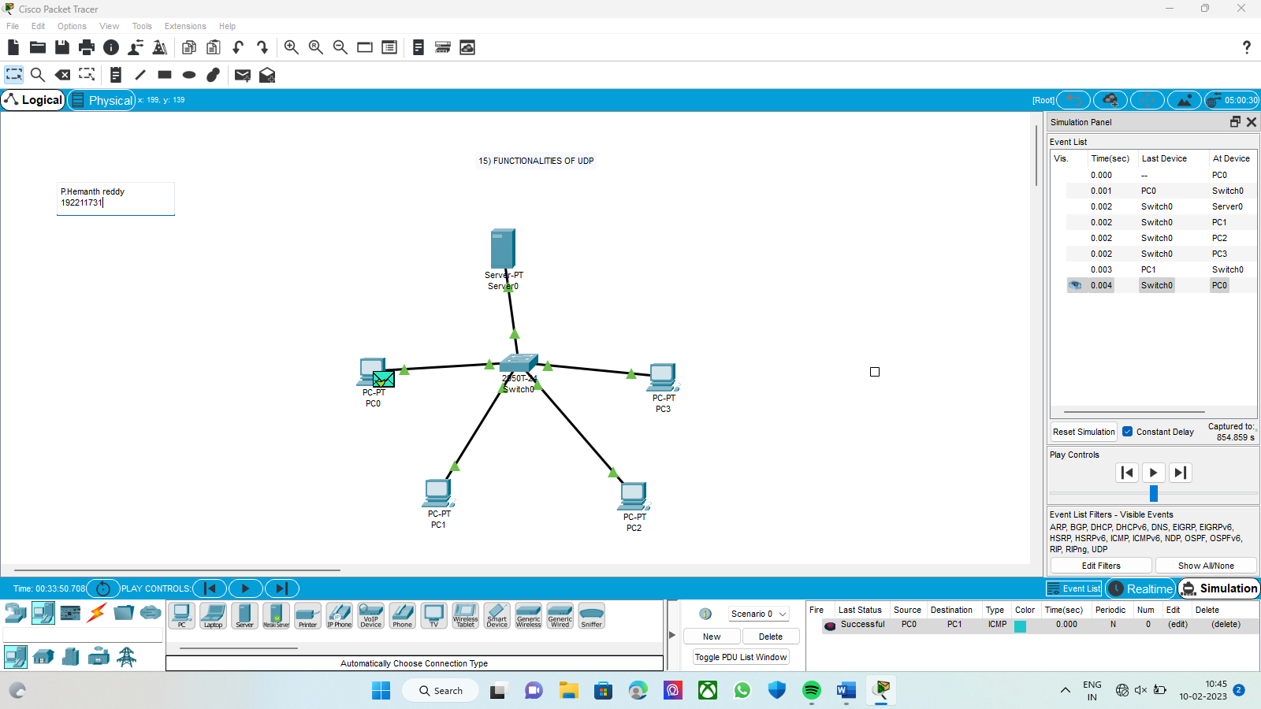

16. SUBNETTING C CLASS ADRESSING

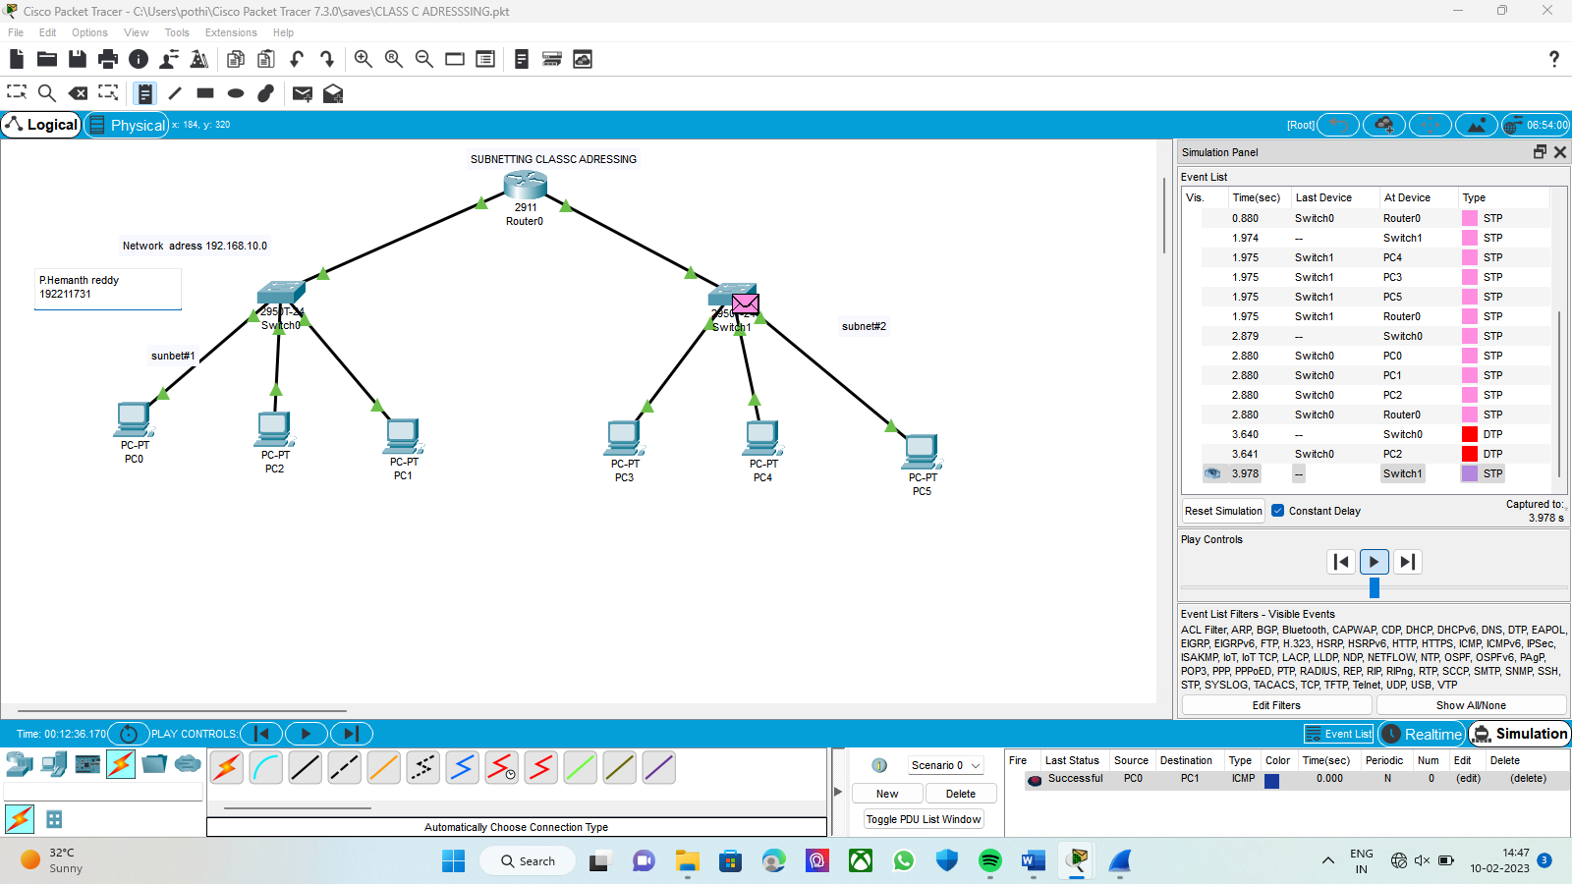

17.SERVER – CLIENT USING TCP

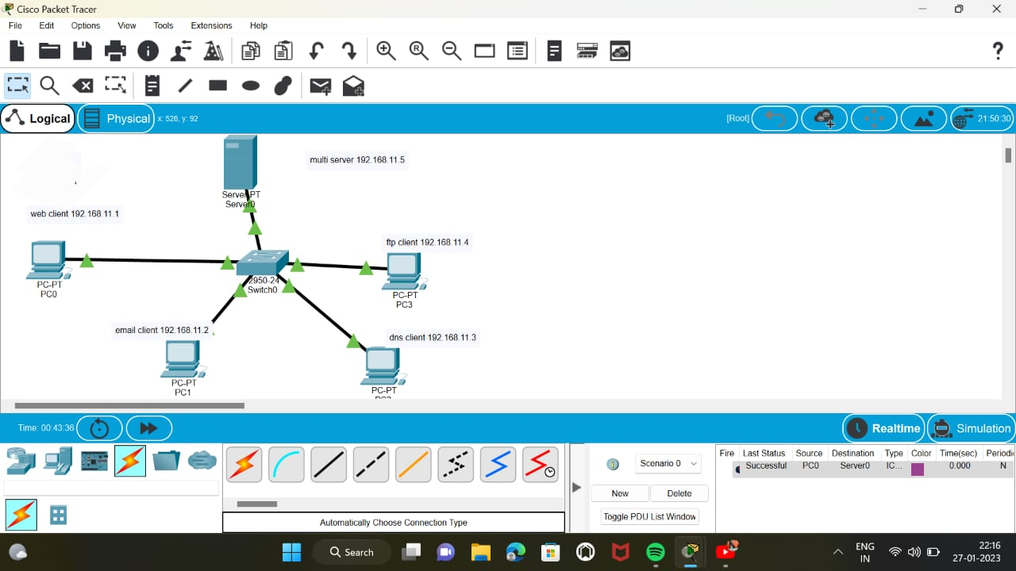

18.SERVER – CLIENT USING UDP

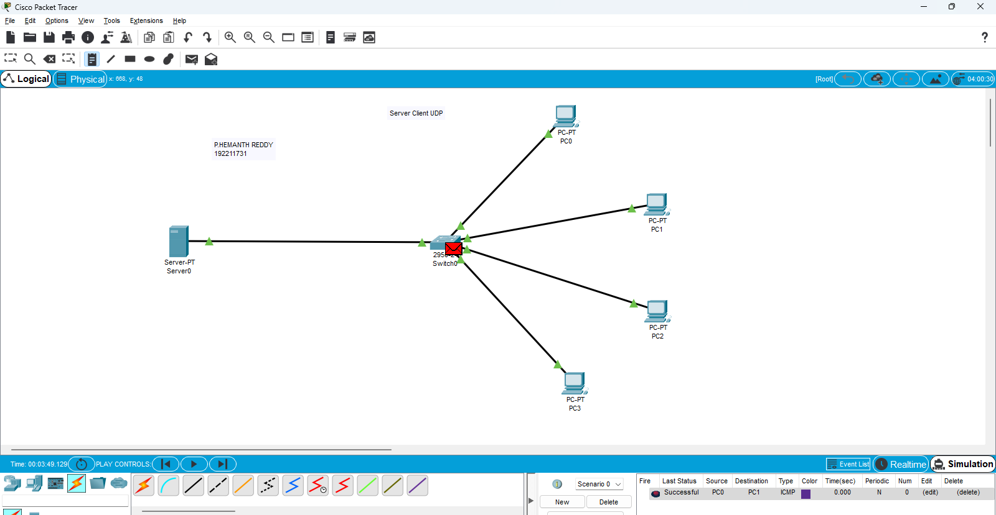

19. X,Y, Z COMPANY NETWORK

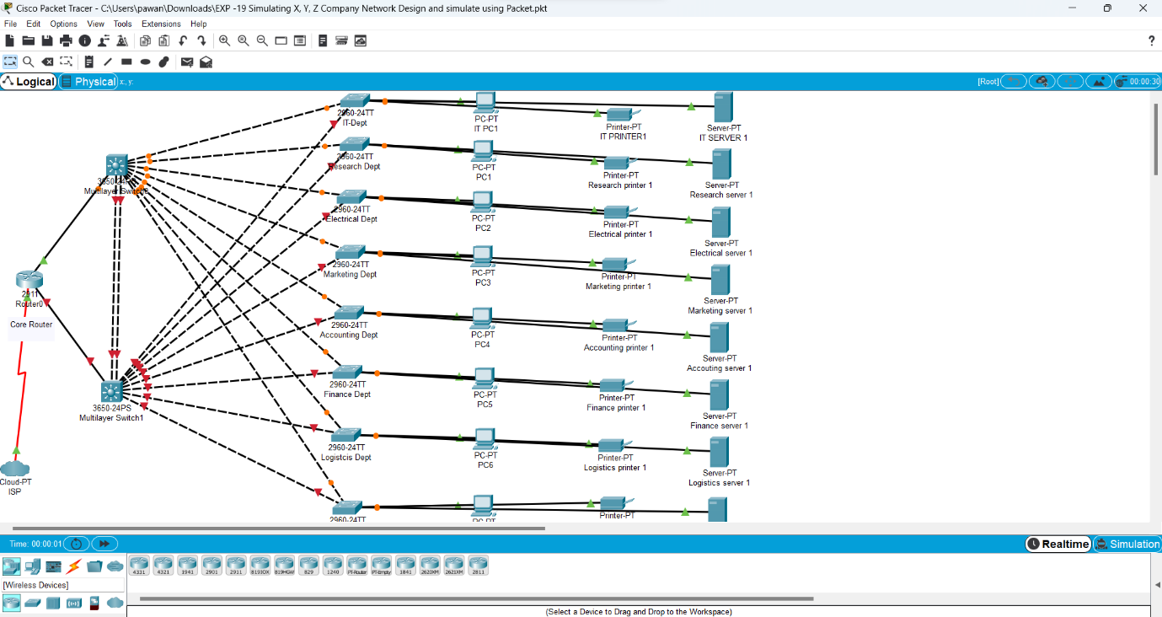

20. DHCP

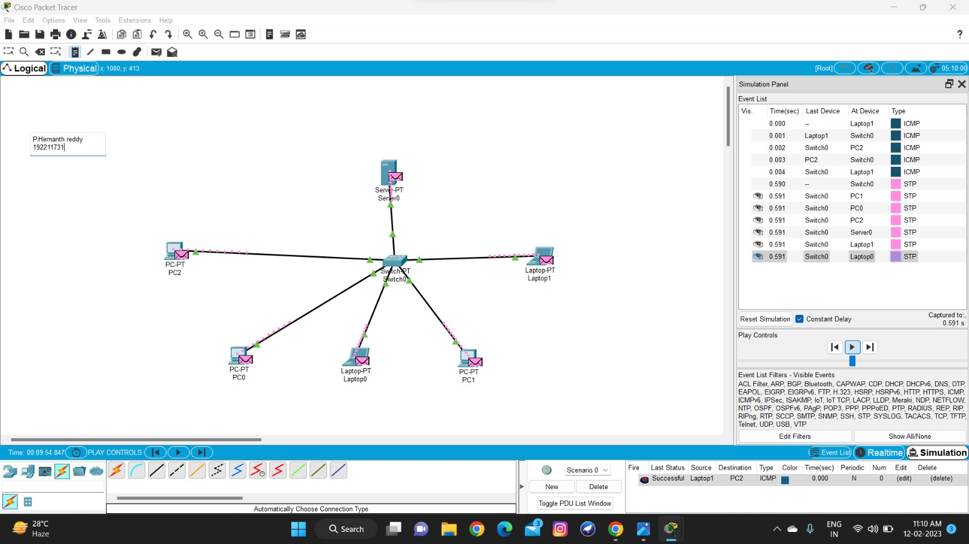

21.FIREWALL

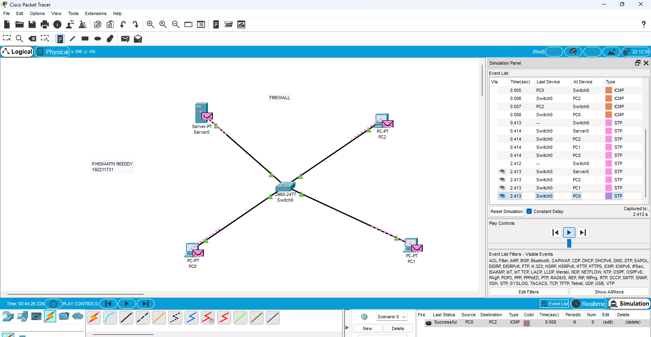

22. COMPUTING LAB

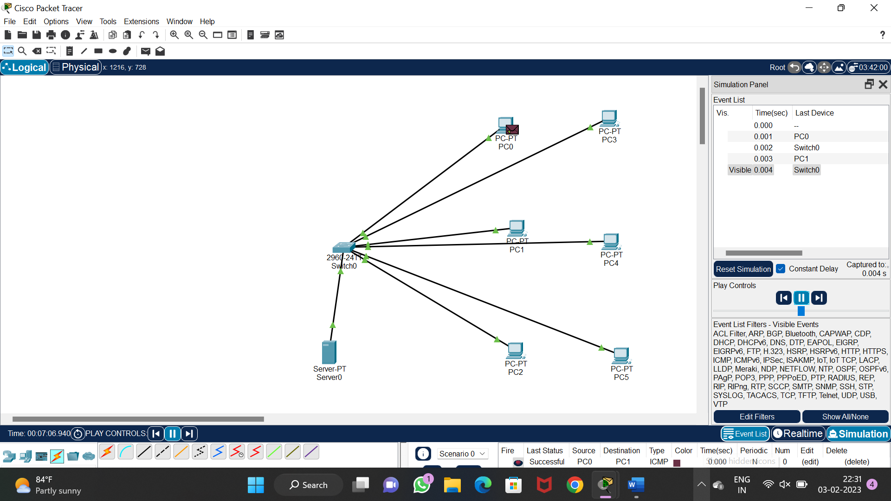

23. WIRESHARK -TCP

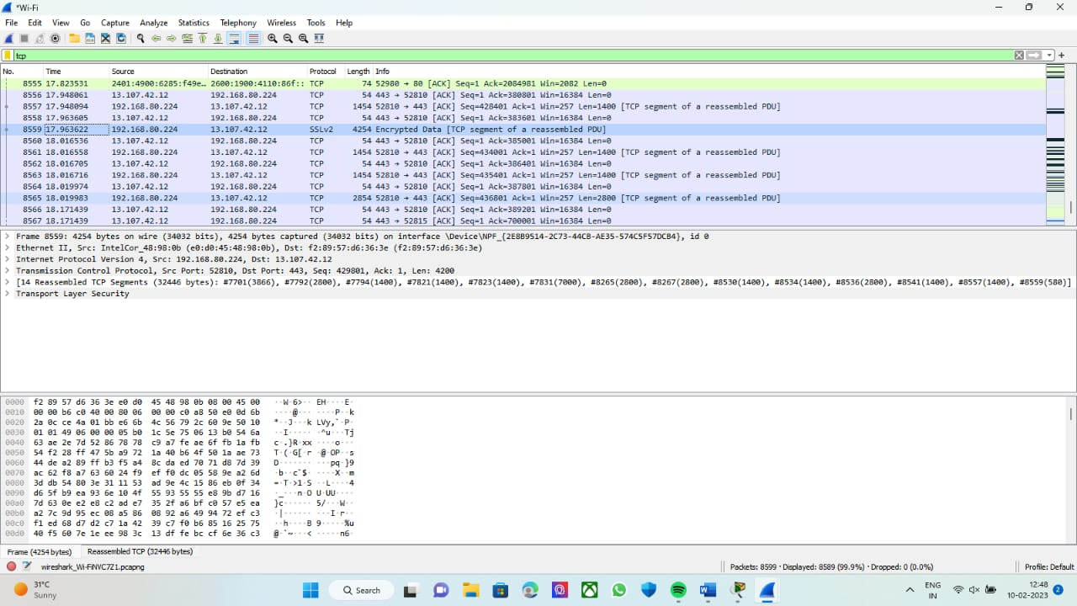

24. WIRESHARK -SMTP

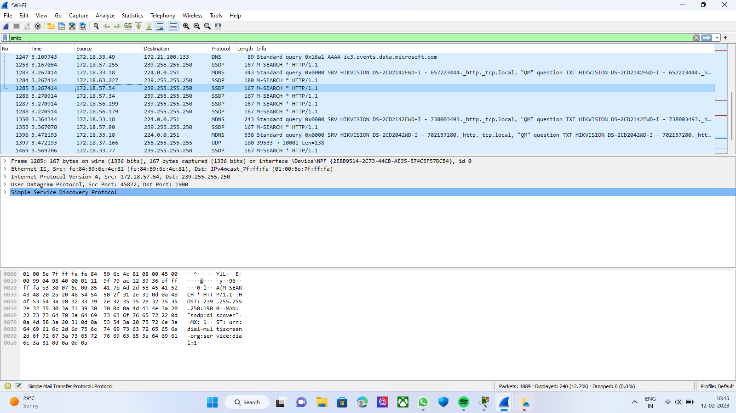

25. . WIRESHARK -ICMP

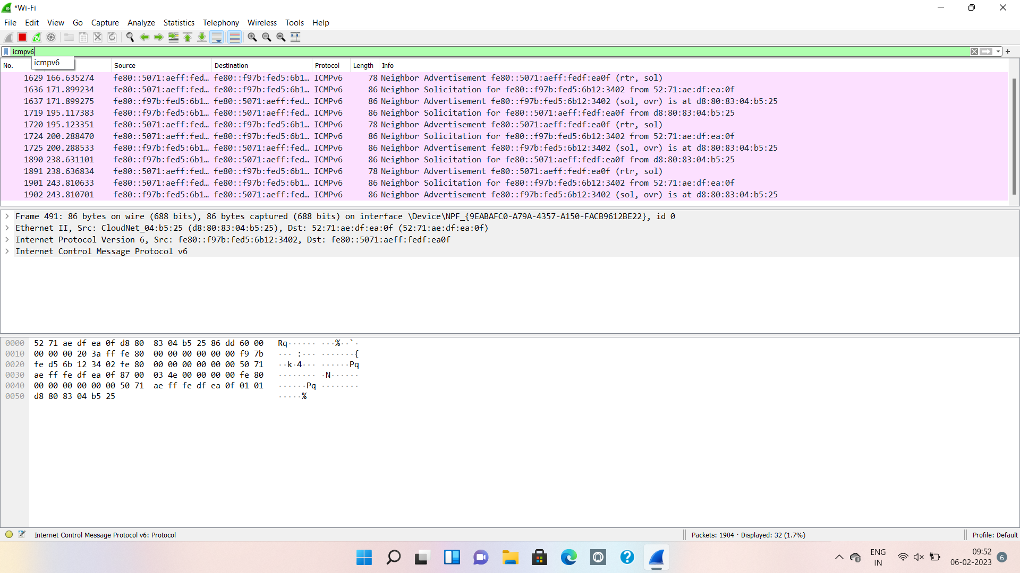

26.WIRESHARK – UDP

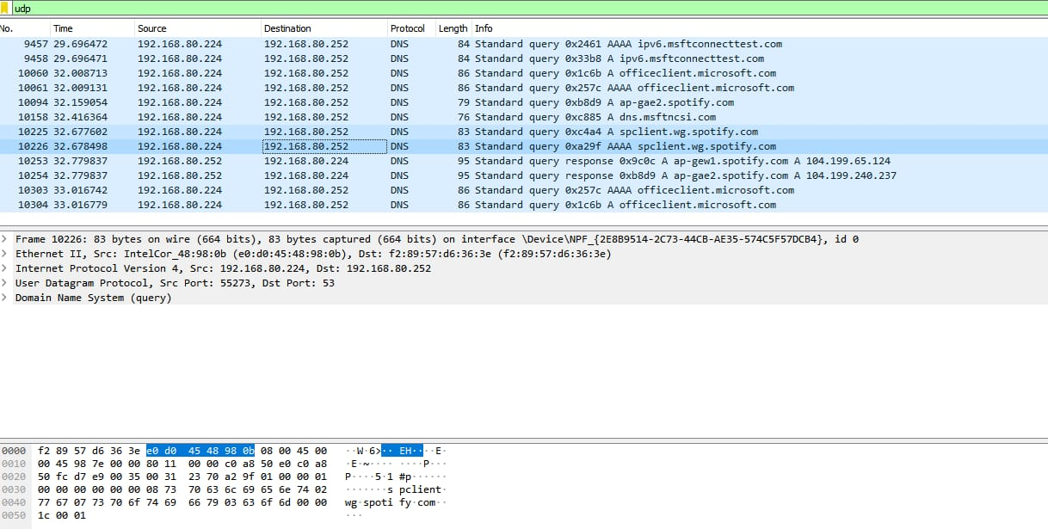

27. WIRESHARK – ARP

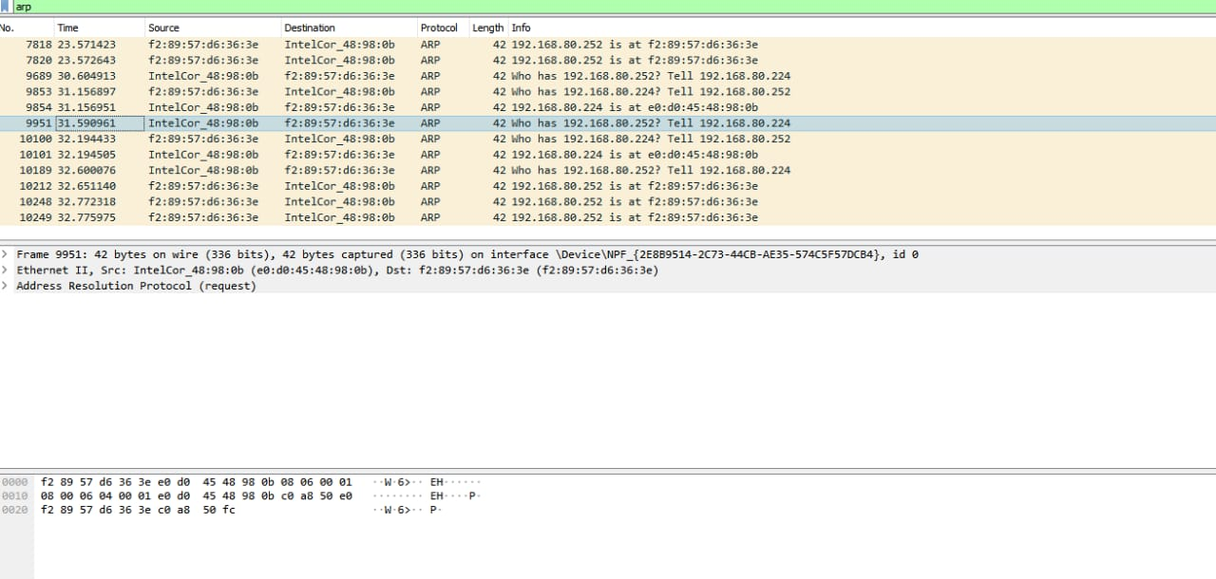

28.WIRESHARK – HTTP

